Report - Scientific Calculator

Name: Shashwat Sinha

Module: C Programming on Multiple Platforms - Project Based Learning Approach

## ****Introduction****

A Calculator is a small (often pocket-sized), usually inexpensive electronic device used to perform the basic operations of arithmetic. This project presents the development of a software-based scientific calculator using Visual Studio Code which includes various operations from as basic as arithmetic operations to as advanced as truth tables for logic gates. The software can be used by anybody in order to calculate easily, effectively and accurately.

## ****Cost and Features****

### **Cost:**

* + Given that the project is well built and all requirements are met, the cost may vary depending on the market.

### **Features:**

* + This scientific calculators perform basic operations along with trigonometric operations and digital electronics functions.
  + Using C language, the model is solved in quick time.

## ****SWOT Analysis****

# 

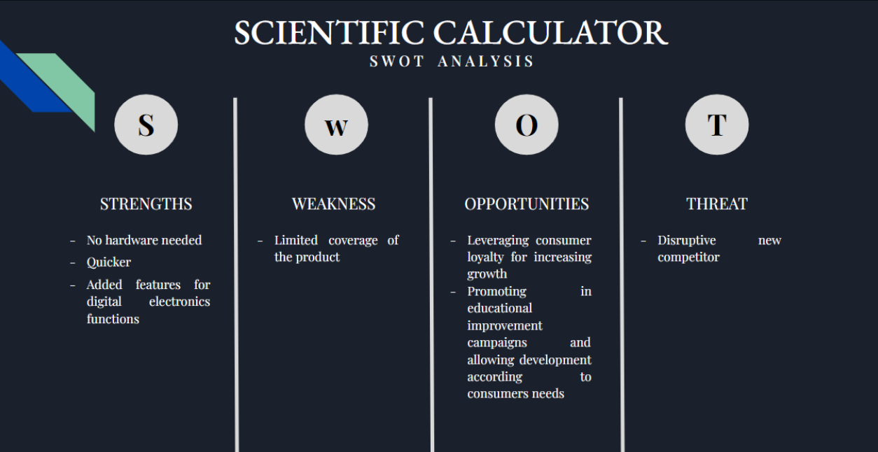

## ****High Level Requirements****

| ID | Description | Status |
| --- | --- | --- |
| HR01 | Arithmetic Operations for two or more numbers | Implemented |
| HR02 | Power, square root and factorial | Implemented |
| HR03 | Trigonometric functions | Implemented |
| HR04 | Basics formulations and logics of digital electronics | Implemented |
| HR05 | Implementation using C Language | Implemented |
| HR06 | User-friendly | Implemented |

## ****Low Level Requirements****

| ID | Description | HRID | Status |
| --- | --- | --- | --- |
| LR01 | For each set of numbers the arithmetic operations are performed and exact output is retrieved | HR05 | Implemented |
| LR02 | The user can perform arithmetic operations on more than two numbers as well exit once they are done with the calculations. | HR01 | Implemented |

# ****Architecture****

### **Use-Case Diagram**

[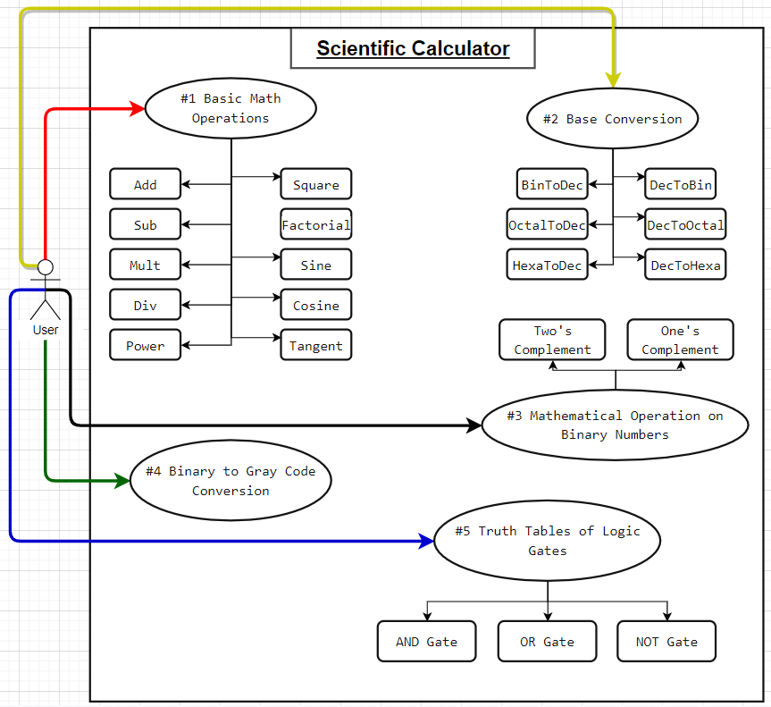](https://github.com/shashwat2811/M1_ScientificCalc_Utility/blob/main/2_Architecture/2022-02-09-21-34-35.png)

### **Flowchart**

[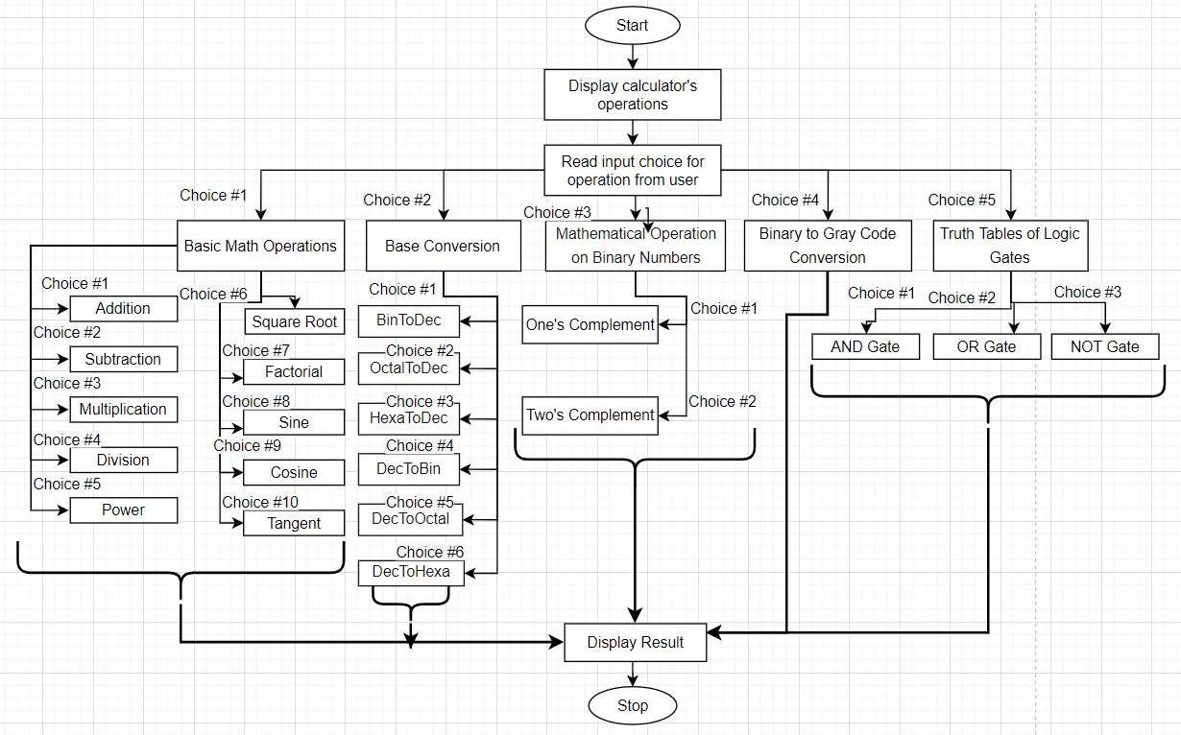](https://github.com/shashwat2811/M1_ScientificCalc_Utility/blob/main/2_Architecture/2022-02-10-00-52-09.png)

## Images and videos showcasing project outputs

## Welcome Screen

**[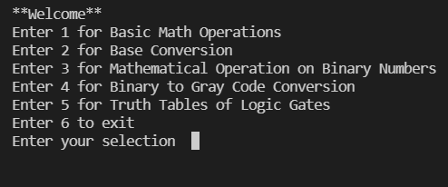](https://github.com/shashwat2811/M1_ScientificCalc_Utility/blob/main/6_ImagesAndVideos/2022-02-12-15-39-44.png)**

## Basic Math Operations

**[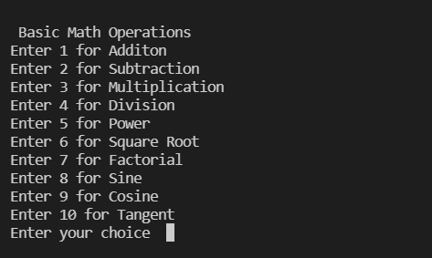](https://github.com/shashwat2811/M1_ScientificCalc_Utility/blob/main/6_ImagesAndVideos/2022-02-12-15-40-39.png)**

## Addition

**[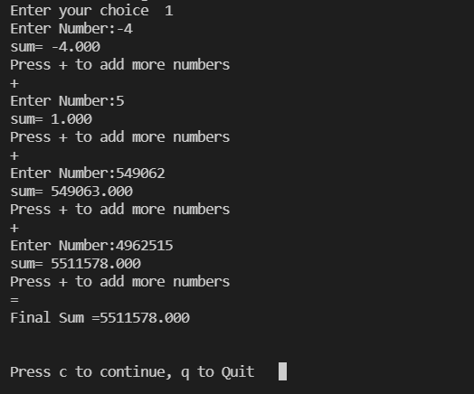](https://github.com/shashwat2811/M1_ScientificCalc_Utility/blob/main/6_ImagesAndVideos/2022-02-12-15-42-56.png)**

## Sine of an angle

**[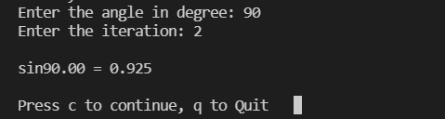](https://github.com/shashwat2811/M1_ScientificCalc_Utility/blob/main/6_ImagesAndVideos/2022-02-12-15-44-20.png)**

## Base Conversion

**[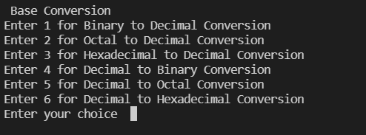](https://github.com/shashwat2811/M1_ScientificCalc_Utility/blob/main/6_ImagesAndVideos/2022-02-12-15-49-34.png)**

## Binary to Decimal Conversion

**[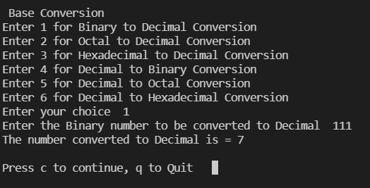](https://github.com/shashwat2811/M1_ScientificCalc_Utility/blob/main/6_ImagesAndVideos/2022-02-12-15-50-17.png)**

## Mathematical Operation on Binary Numbers

**[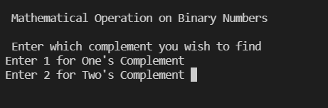](https://github.com/shashwat2811/M1_ScientificCalc_Utility/blob/main/6_ImagesAndVideos/2022-02-12-15-54-47.png)**

## One's Complement

**[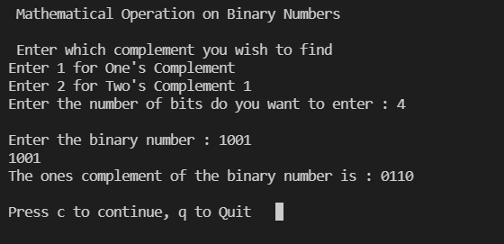](https://github.com/shashwat2811/M1_ScientificCalc_Utility/blob/main/6_ImagesAndVideos/2022-02-12-15-56-40.png)**

## Binary to Gray Code Conversion

**[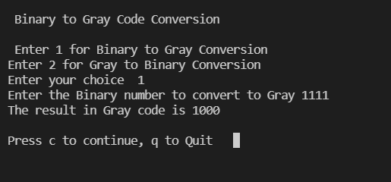](https://github.com/shashwat2811/M1_ScientificCalc_Utility/blob/main/6_ImagesAndVideos/2022-02-12-16-02-31.png)**

## Truth Tables of Logic Gates

**[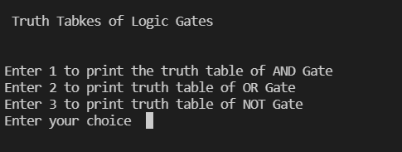](https://github.com/shashwat2811/M1_ScientificCalc_Utility/blob/main/6_ImagesAndVideos/2022-02-12-16-11-29.png)**

## Truth Table of AND Gate

**[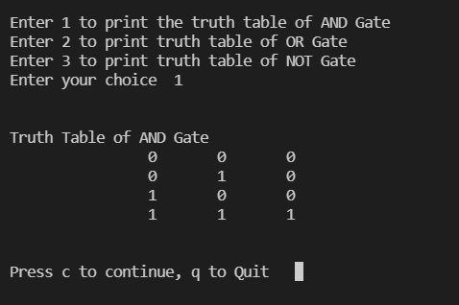](https://github.com/shashwat2811/M1_ScientificCalc_Utility/blob/main/6_ImagesAndVideos/2022-02-12-16-15-43.png)**

## References

1. [Maclaurin series expansions for Trigonometric Functions](https://en.wikipedia.org/wiki/Taylor_series)
2. [Digital Electronics Calculator in C](https://github.com/chandantaluja/Digital-Electronics-Calculator-in-C-Ver-1.0.0)
3. [Smart-Delivery-App_MiniProject-C](https://github.com/JeevakRaj/Smart-Delivery-App_MiniProject-C)